SEG 2105
Introduction to Software Engineering
Fall 2018

Final Report
On-Demand Home Repair Services App

Presented To
Miguel Garzon

Nunavik Group

Abbey Kerkmann, 300007054
Luiz Nogueira Capitulino 8900638
Peter Haddad, 8572957
Paul-André Abou Zeid, 8649144

School of Electrical Engineering and Computer Science
University of Ottawa

Introduction

We have developed an on-demand home repair services android app modeled to allow homeowners to efficiently and effectively find a service provider who specializes in a specific trade, such as plumbing, construction or housekeeping.

The application was created with three possible types of users:
- The administrator, who is capable of adding, removing and editing services that will be offered to the homeowners.
- The service provider, who can complete an information profile that includes information needed by homeowners. In addition, a service provider can select the appropriate category based on the service offered.
- The homeowner, who can select amongst a list the service that he or she wishes to book. A homeowner’s search of a service provider can be enhanced by searching using specific parameters, such as the name of service, booking time or rating.

This report will provide an overview of the various deliverables for our application, in addition to the updated UML class diagram and screenshots of the user interface.

Team Roles and Contribution

Name | Deliverable 1 | Deliverable 2 | Deliverable 3 | Deliverable 4
Luiz Nogueira Capitulino | 30 | 30 | 30 | 30
Abbey Kerkmann | 23 | 23 | 23 | 23
Peter Haddad | 23 | 23 | 23 | 23
Paul-André  Abou Zeid | 23 | 23 | 23 | 23

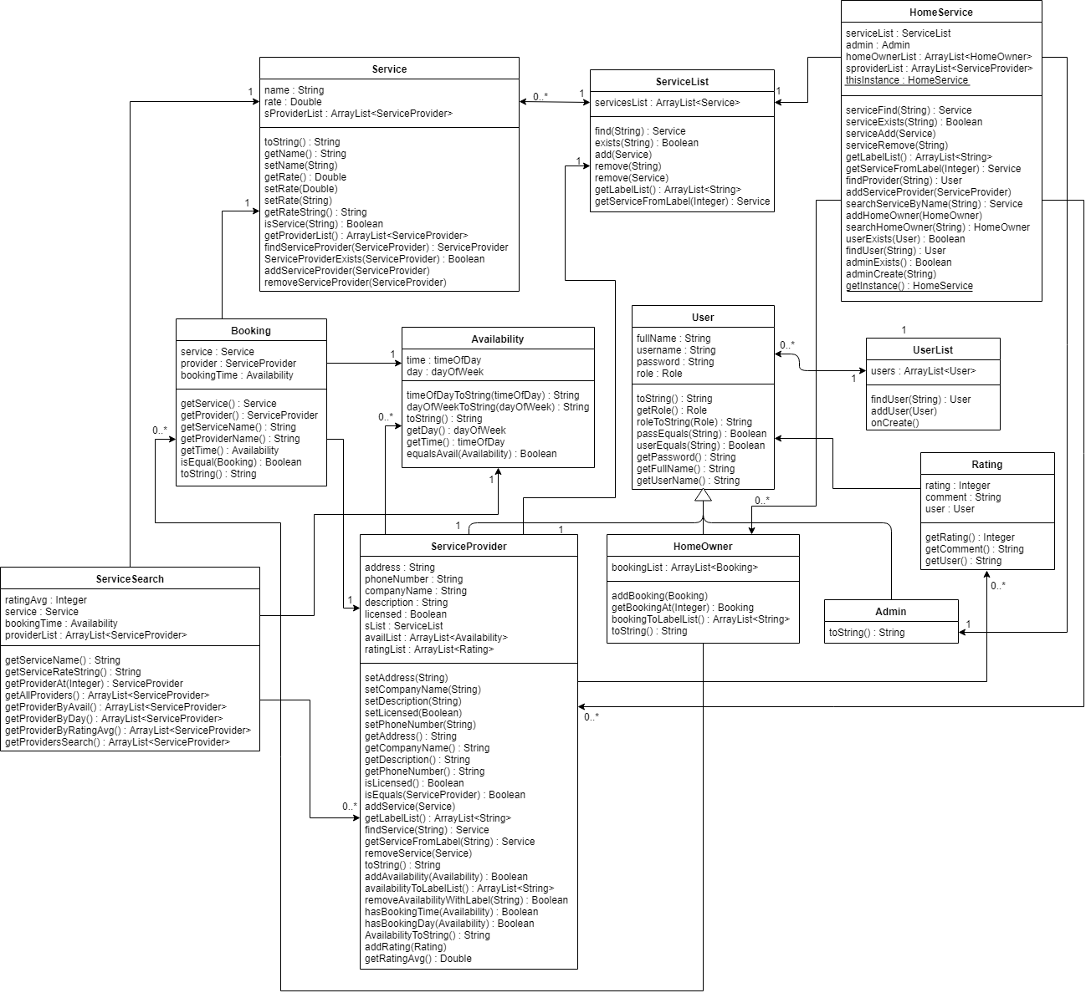
UML Class Diagram

Screenshots

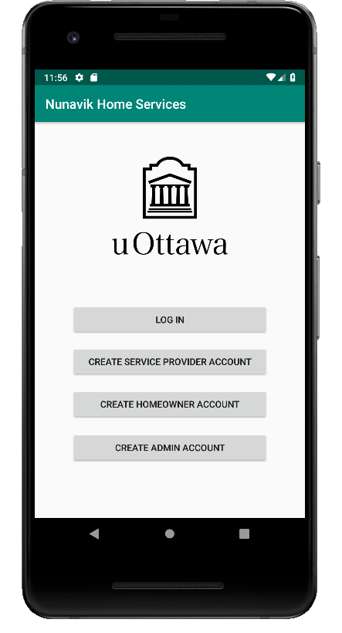
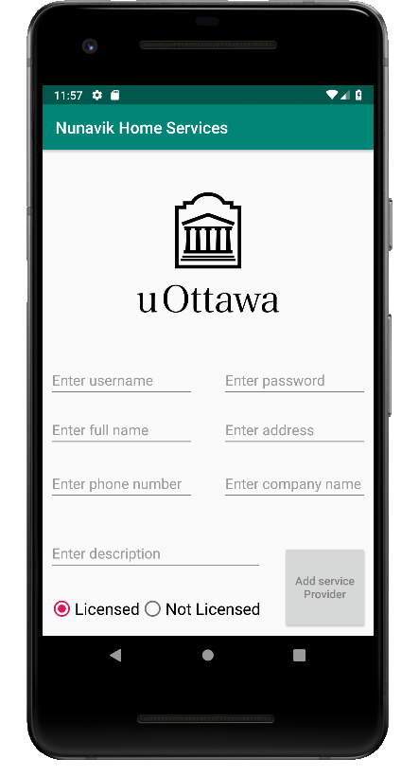
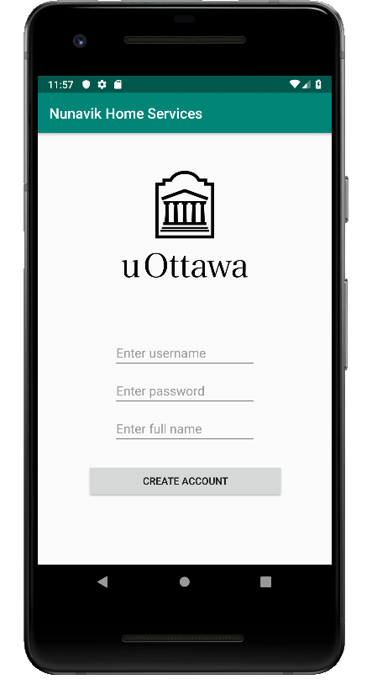
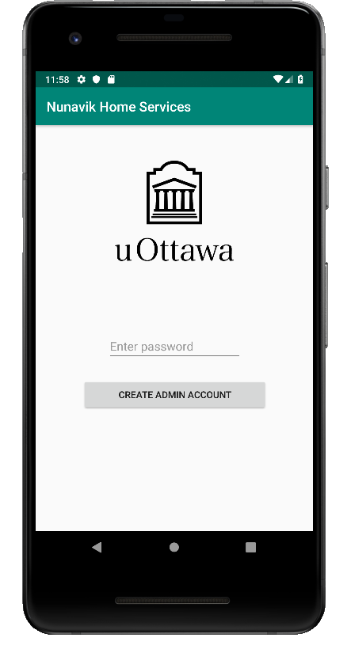

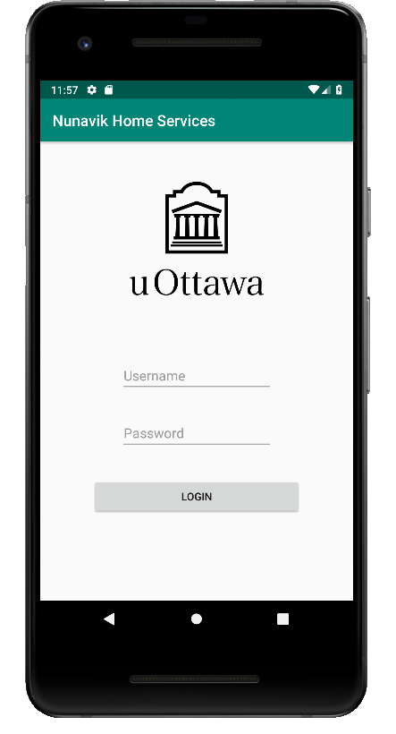
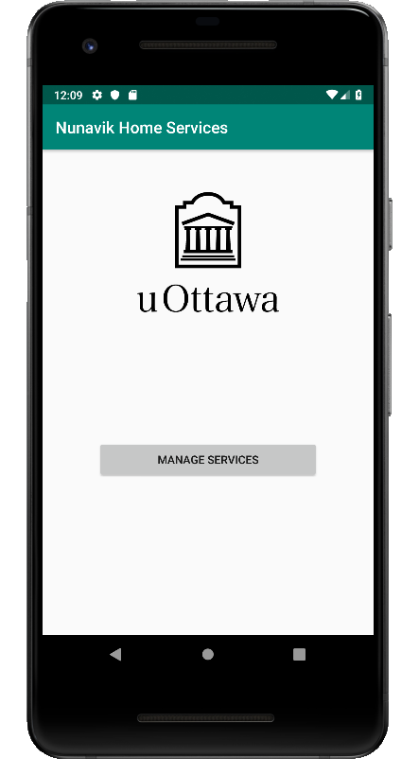
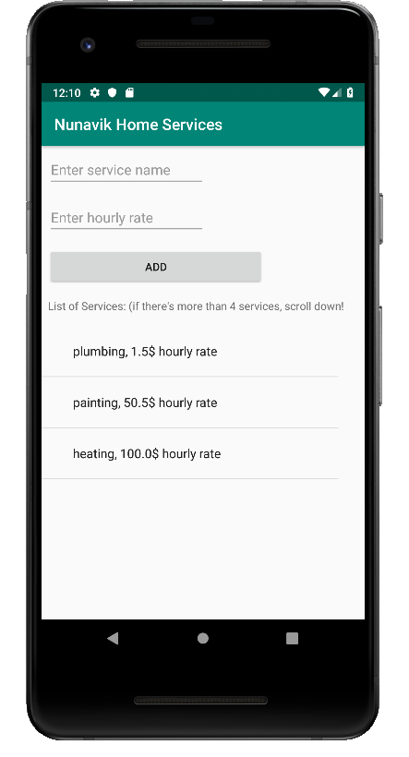
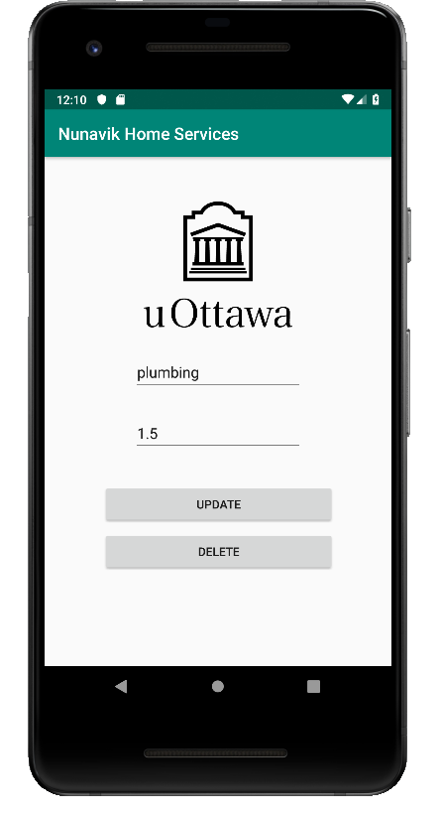

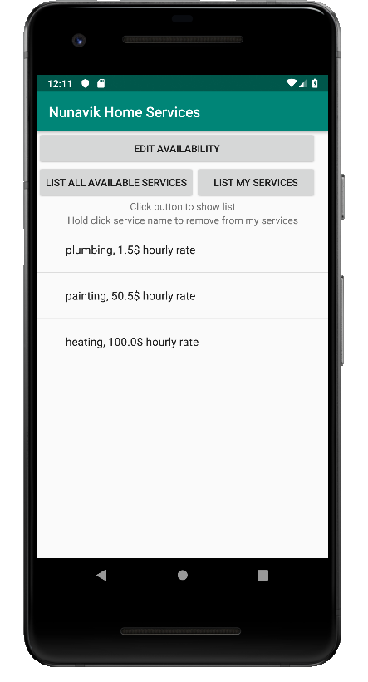
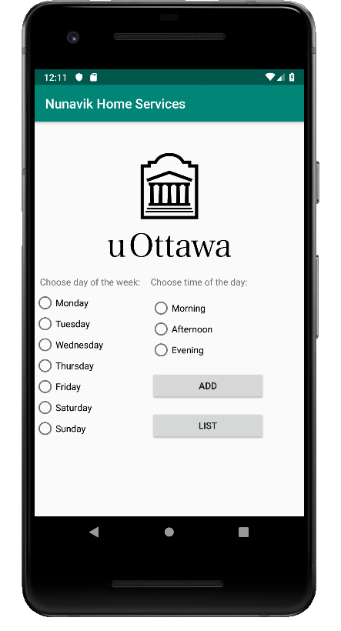
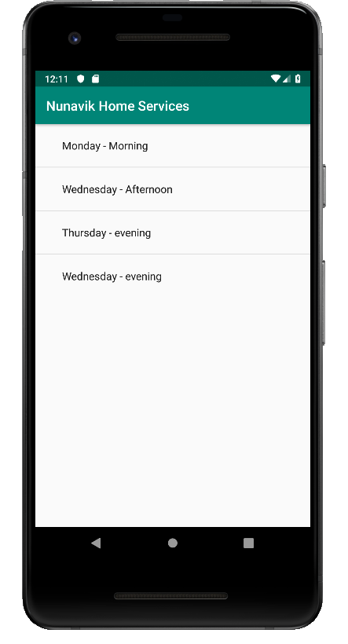
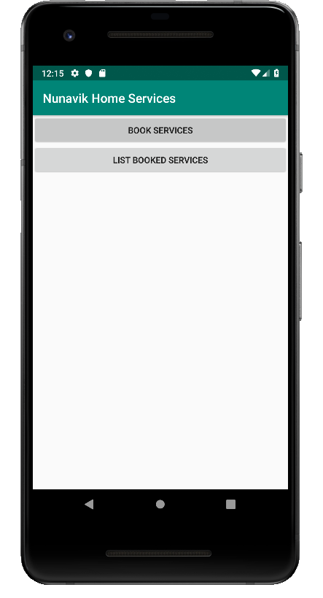

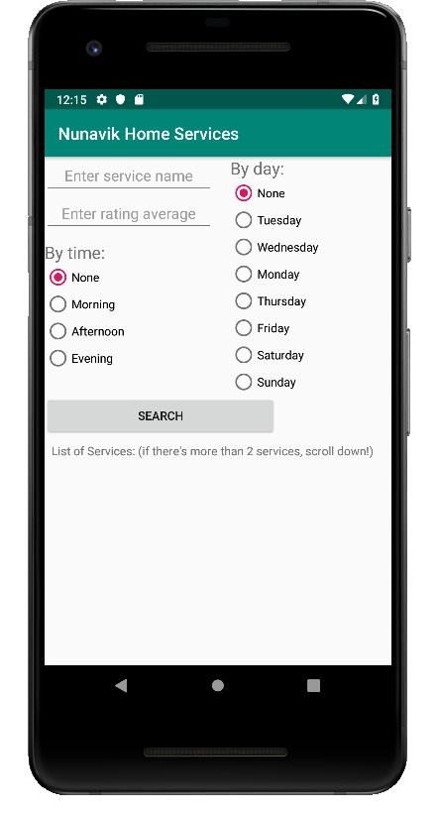
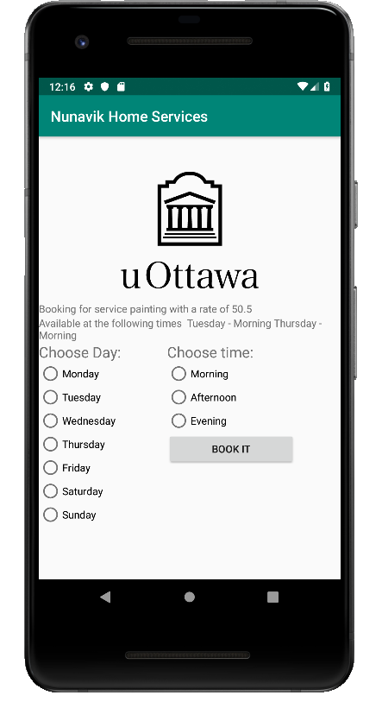

Lessons learned

An important lesson we have learned throughout this project is the fundamental aspect of working in a team. Early on in the development, we quickly determined the strengths and weaknesses of each member. Subsequently, we were able to split up the necessities of the application into parts, and delegate each part to a specific group member. This ensured that the individual in question would be well diverse in the matter at hand, and most importantly, be interested and motivated to work on this aspect of the application. In addition, we also discovered that communication amongst all group members is imperative to the success and effectiveness of our application. With such a complex and detailed project at hand, we quickly concluded that constant communication would be a necessity in order to avoid confusion and to ensure every deliverable was completed with utmost efficiency and quality. In order to communicate with each other, we frequently provided status updates regarding our delegated tasks via email. This ensured that everyone would be caught up in the progress of the development, regardless if you were responsible for a specific task or not. Most importantly, it establishes a timeframe for each part to avoid missing the submission deadline. Furthermore, we constantly asked each other for advice whenever a problem appeared. With this system in place for each deliverable, we were able to successfully implement our application without any major issues.

Another lesson learned was the importance of determining the main priorities in the process of developing our application. Once we had analyzed the deliverable marking schemes, we quickly realized that due to time constraints and the number of tasks required, we had to prioritize what was essential and disregard any extra functions we were interested in implementing. This included focusing keeping a clean and simple UI in order to reserve more time and efforts into the coding the functionalities of the application. In addition, we decided to focus on the main functionalities and not spend time implementing the bonus features. This also allowed us to enhance our familiarity with the implementation to properly design our UML class diagram for each deliverable.

Finally, we’ve learned the fundamentals of developing an application in Android Studio. This includes designing a user interface, as well as building and testing Android applications. In today’s society, we rely on mobile apps to assist us in our day to day lives. The sheer amount of applications available in today’s technological setting can suggest to a novice user that application development is a relatively simple task. However, this project has helped us to understand the complexity that is behind developing an Android application.

